TO: Alfred Hitchcock and Team

FROM: Alexandria Mlkvy

SUBJECT: Social Media Proposal

DATE: October 6th, 2014

Introduction

In today’s world, pre-release engagement with the audience is essential in order to create a following and get them interested. Companies compete to create the next great film, while simultaneously trying to figure out the best way to market it to consumers. Vine is a social media platform that allows its users to share six-second video clips with their followers. While the six-second video sounds short, the proper editing of footage allows for endless possibilities to reach people in an entertaining way.

I believe that the creation of a personal account on this app will allow you to make a deeper connection with your audience. I will describe Vine – who uses it, why using this social media platform is important, and what other companies are doing. Then, I will explain how we can use this app to create awareness and hype surrounding your thrilling films. I will use your next great film, Psycho, as an example. Finally, I will explain the long-term benefits for using Vine to create content that will engage your audience, as well as how we can use the app to promote your movies. I will use examples from other companies that have successfully used Vine in the past to show you what we can do with this application.

Current Situation

All forms of social media have become an increasingly important part of today’s culture, which means that, as a prominent figure in Hollywood, it is in your best interest to hop on the bandwagon and get a social media account or two. While traditional ways of reaching out to your audiences such as guest appearances, interviews, and previews of films have proven effective in the past, social media opens up a whole new world of opportunities as well as a whole new audience. I believe that Vine is the best way for you to ease into social media because it deals with film - a medium you are already very familiar with.

Vine is an application, for both iPhones and Android devices, that was launched in January 2013 by Twitter that allows users to create and share six-second looping videos with their followers. The six-second films can be shot continuously, or broken up into smaller frames that are strung together to create a single video. Vine also recently updated the app to allow users can also use footage stored on their phone to create videos. These videos can be viewed on the Vine app, on a Twitter or Facebook feed, or can be embedded onto a web page for easier viewing, so those who don’t have the app can view your videos.

How to Use Vine

Before You Get Creative:
Before you dive into content-creation mode it is important to explore Vine and it’s basic features. The Explore page (figure 1.1) allows you to search for hashtags and users, view popular videos, and explore various categories. Also take a look at your profile (figure 1.2) – upload a photo for your avatar, write a bio, and add a location. You will also be able to access your settings from your profile page. Because you are a public figure, set your profile to public – it will allow those who don’t follow you to view your Vines. Your profile is also where you can view your previously posted Vines.

It is also important to follow other users. Search Vine to find influential users who have a strong following. Once you follow users, the Vines they post will show up on your home feed (figure 1.3) when you open the app.

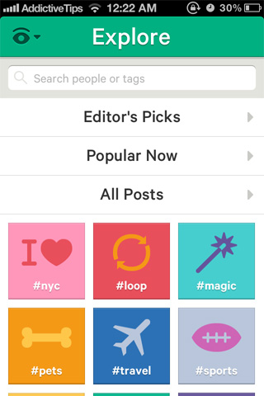

Figure 1.3
Figure 1.1
Figure 1.2

Step One:
The first step in creating a Vine is to come up with an idea of what kind of content you want to create. Brands have used Vine create stop-motion videos, cartoons, behind-scene-looks, teasers, and other clips to entertain and inform their audience.

Step Two:
To begin filming a Vine, hold your finger on the screen to capture the desired clip. (Figure 1.4) Placing your finger on the screen begins recording, and removing your finger pauses it. You can record as many clips as you would like – Vines can be as short as three seconds or as long as six. Vine also allows users to upload previously recorded videos from their mobile devices to create a Vine. The green bar across the top of the screen shows you how much time you have used the black section shows how much time you have left. (Figure 1.5)

Step Three:
Once you have filmed all your clips you can change the order by clicking the “edit” button and dragging them to their proper place. You can also delete clips by dragging them to the trashcan icon.

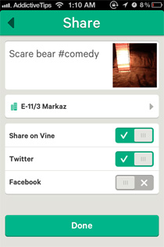
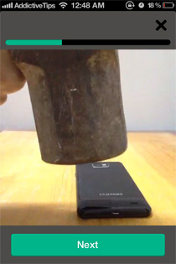
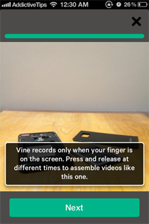
If you are satisfied with your Vine, press Save and then click the green check mark at the bottom of your screen. You will then arrive at the “Share” page where you can add a caption, location, and channel to tag your video. (See figure 1.6) Selecting a channel allows you to choose a category to put your Vine into such as comedy, food, and cats, which will also make it easier for users to find your Vine. You can also share Vines on other social media accounts. Once you have posted the Vine, others can like the Vine as well as ReVine it, which means that they post the video on their account to share with their followers.
Figure 1.6
Figure 1.5
Figure 1.4

Hashtag:
When creating a caption, the use of a hashtag (#) or two is essential in order to your video to be seen by other users who aren’t following you. A hashtag is a combination or words or numbers preceded by a pound sign (#) that links a post to other posts with the same hashtag. They allow for organization of posts of the same topic. So, if you were creating a movie teaser or a behind the scenes look at the movie Psycho, you could use #psycho to tag your posts. When others search for #psycho, your post would show up along with posts from other users that contain that hashtag. Special characters and punctuation marks cannot be used in a hashtag.

Important Features:
Vine offers features to help to you create a video such as a grid for stable shooting, a focus button, a “ghosting” tool, and a “save draft” option. The “ghosting” tool is particularly useful when creating stop-motion animations because it shows the last frame captured which allows you to line up objects and create fluid transitions. The “save draft” option allows users to save and work on your video up to 10 times.

Users who view your Vine also have the ability to like the video and leave comments. This is an important feature because it allows fans or followers to give you feedback. For example, if you post a teaser of an upcoming film, users can let you know what they think about the preview or how excited they are. This also gives you the ability to respond to them.

Implementation

After creating an account, you can jump right in and start posting content using the steps listed above. Like I mentioned previously, Vine’s filming flexibility allows for endless possibilities.

When creating a Vine though it is important to consider your audience – what will they want to see from you? Because you are an important figure in Hollywood that can seem quite distant from the average person, it is important to humanize yourself and show the mundane tasks of your everyday life.

One of the greatest things about social media is that you don’t need a reason to post – you can make a Vine about your breakfast or a walk in the park. Six seconds is a short amount of time so you have to use it wisely. You can post monthly, weekly, daily, or whenever you feel like. The more you post the more content you will share with your audience.

You can also make short films on Vine when you’re directing the next great film. In April 2013, Tribeca Film Festival hosted a #6SecFilm Vine competition. They had over 400 entries and chose the top two films in four categories. This competition shows how creative and inventive you can get with this limited amount of time. The winning Vines can be viewed here: tribecafilm.com/stories/winners-6-second-films-vine-competition

Another great use for your Vine account is the marketing of movies. From your account you can post a behind-the-scenes look or a quick teaser. For most of your movies, Psycho especially, you have tried to avoid traditional media to keep the plot a secret. The short, six-second nature of Vine videos allow you to create a short teaser of clips to share with the audience.

This particular strategy has recently been used for several movies. According to business2community.com, in March 2013 The Wolverine became the first movie to use Vine to release the first preview. The teaser packed at least a dozen frames into six seconds which they used to build excitement for the 20-second trailer.

Olympus Has Fallen was another movie that released a short preview via Vine. According to deadline.com, after the movie was released they encouraged users to create their own “6-Second Review” on Vine. All of the reviews were then placed on Olympus6SecReviews.com. They called users to action by asking them to review the film on the app. This strategy can draw attention to the film while also creating a conversation among users. This is also a chance to gather feedback.

Benefits

The creation of a Vine account in your name will allow you to not only reach a new audience, but also establish relationships with those who follow you. Like other social media platforms, the use of Vine will allow you to
- Increase your visibility
Figure 1.7
- Help you connect and communicate with your audience
- Create contest
- Build and promote your brand
- Give the public an inside look
- Tell a story

The important features of Vine previously mentioned will allow you to create engaging content that can be shared with the digital community. Creative content that is different has the tendency to be shared and become popular – the more creative you get, the better chance of your content being seen.

This infographic from Mashable.com summarizes other important statistics and reasons to use Vine:
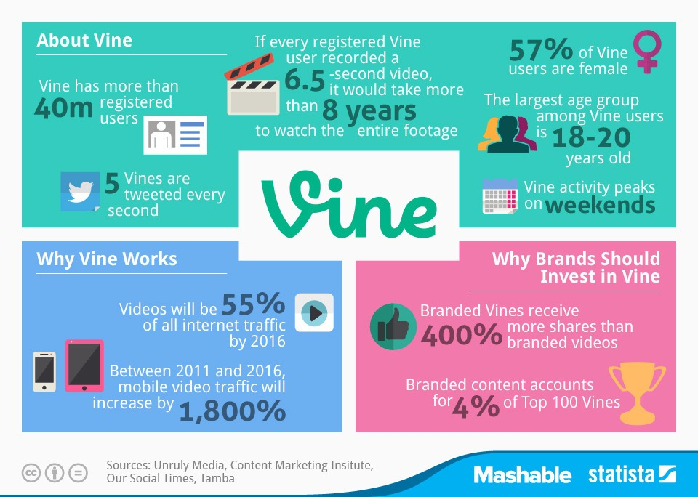
As you can see from this infographic, Vine is a growing social media platform that is benefical for any company or person to use in order to connect with their audience.

Conclusion

Vine is a social media platform with many features that would be beneficial to you and your occupation in terms of reaching out to your audience. I feel that with your creative mind and knowledge of film techniques, you will excel at creating content that your audience will love – both in regards to your films and your personal life. This easy-to-use application with a growing user-base is the first step for you into the social media world because it deals with a genre you are already familiar with – film.Overall, this is a well laid out plan for Hitchcock to use Vine. However, I did think there were areas that you could’ve provided a bit more information. Remember, the proposal should provide enough information that it answers any questions the client might have, so including all the kinds of content he would create or contests he might have would be helpful to him in making decisions. 135/150

Works Cited
Hutchins, Bob. "Is Vine the Next Secret Weapon in Movie Marketing?" Business 2 Community. N.p., 19 Aug. 2013. Web. 17 Oct. 2014. <http://www.business2community.com/social-media/is-vine-the-next-secret-weapon-in-movie-marketing-0582055>.
Imran, Awais. "Vine By Twitter Is A Network For Sharing Short, Looped Video Clips." AddictiveTips. N.p., 26 Jan. 2013. Web. 17 Oct. 2014. <http://www.addictivetips.com/ios/vine-by-twitter-is-a-network-for-sharing-short-looped-video-clips/>.
Knoblauch, Max. "The Beginner's Guide to Vine." Mashable. N.p., 11 Dec. 2013. Web. 16 Oct. 2014. <http://mashable.com/2013/12/11/vine-beginners-guide/>.
Peele, Stanton. "Personality, Pathology, and the Act of Creation: The Case of Alfred Hitchcock." The Stanton Peele Addiction Website. N.p., n.d. Web. 16 Oct. 2014. <http%3A%2F%2Fwww.peele.net%2Flib%2Fhitch.html>.
Robertson, Linsay. "Announcing the Winners of Our #6SECFILMS Vine Competition | Tribeca." Tribeca. N.p., n.d. Web. 17 Oct. 2014. <http://tribecafilm.com/stories/winners-6-second-films-vine-competition>.
Singh, Kyli. "It Would Take You 8 Years to Watch a Vine Video From Every User." Mashable. N.p., 16 July 2014. Web. 16 Oct. 2014. <http://mashable.com/2014/07/16/vine-statistics/>.

